**University of Westminster**

**Module Name:**  Software Development 1

**Module leader**: Guhanathan Poravi

**Assignment type:** Individual coursework

**Task : E,D**

**Group ID**: 24

**Submission date:** 24.12.2024

|  |  |  |
| --- | --- | --- |
| **Student Id** | **Uow ID** | **Student Name** |
| 20231259 | w2120290 | H. I. A. Haneef |

**School of Computing**

**Informatics Institute of Technology (IIT Campus)**

Table of Contents

Pseudocode for CSV Data processing program 1

Program description: 1

Steps of the Program: 1

Test cases 8

Test cases and their outcomes. 8

Test case 1 outcomes 9

Test case 2 outcomes 10

Test case 3 outcomes 10

Test case 4 outcomes 11

Test case 5 outcomes 12

Test case 6 outcomes 12

Table of figures

Figure 1: Case 1 outcomes 9

Figure 2: case 2 outcomes 10

Figure 3 :case 3 outcomes 10

Figure 4: case 4 outcomes 1 11

Figure 5: case 4 outcomes 2 11

Figure 6: case 4 outcome 3 11

Figure 7: case 4 outcome 4 12

Figure 8: Case 5 outcomes 12

Figure 9 : case 6 outcomes 1 13

Figure 10 : case 6 outcomes 2 13

# Pseudocode for CSV Data processing program

## Program description:

The program processes traffic data from a CSV file and calculates various metrics, such as the number of vehicles, trucks, buses, electric vehicles, and speed violations. It interacts with the user to validate input, display results, and save them to a file and then the program creates a histogram to display the number of vehicles passing through the two junctions each hour on the selected date. Users can choose to process multiple datasets in a single session.

## Steps of the Program:

# PROGRAM Traffic Data Analysis and Visualization

BEGIN

CLASS HistogramApp

METHOD __init__(traffic_data, date)

SET self.traffic_data = traffic_data

SET self.date = date

# Extract hour values for Hanley Highway/Westway

INITIALIZE list_of_times_hanley_highway as empty list

FOR each inner_list in traffic_data

IF inner_list[0] == 'Hanley Highway/Westway'

APPEND inner_list[2].split(":")[0] to list_of_times_hanley_highway

# Count vehicles per hour for Hanley Highway

INITIALIZE hour_count_Hanley_Highway as empty dictionary

FOR each hour in list_of_times_hanley_highway

INITIALIZE count = 0

FOR each j in list_of_times_hanley_highway

IF hour == j

INCREMENT count

SET hour_count_Hanley_Highway[hour] = count

# Extract hour values for Elm Avenue/Rabbit Road

INITIALIZE list_of_times_Elm_Avenue as empty list

FOR each inner_list in traffic_data

IF inner_list[0] == 'Elm Avenue/Rabbit Road'

APPEND inner_list[2].split(":")[0] to list_of_times_Elm_Avenue

# Count vehicles per hour for Elm Avenue

INITIALIZE hour_count_Elm_Avenue as empty dictionary

FOR each hour in list_of_times_Elm_Avenue

INITIALIZE count = 0

FOR each j in list_of_times_Elm_Avenue

IF hour == j

INCREMENT count

SET hour_count_Elm_Avenue[hour] = count

# Store the hour counts in a nested dictionary

SET self.traffic_data = {"Elm_Avenue": hour_count_Elm_Avenue, "Hanley_Highway": hour_count_Hanley_Highway}

METHOD setup_window()

CREATE a window with title "Histogram" and dimensions 1200x600

SET background color to black

METHOD draw_histogram()

DRAW horizontal line for histogram

SET parameters for grouped histogram (num_groups, line_length, space_between_groups)

CALCULATE group_length

SET max_height = 400

GET max_traffic_value from both datasets

CALCULATE scaler = max_height / max_traffic_value

FOR group from 0 to num_groups - 1

CALCULATE group_start_x

SET group_key = formatted group number (e.g., '00', '01', etc.)

TRY

GET height_for_Elm_Avenue_triangle from traffic_data

GET height_for_Hanley_Highway_triangle from traffic_data

EXCEPT KeyError

SET height_for_Elm_Avenue_triangle = 0

SET height_for_Hanley_Highway_triangle = 0

# Scale the heights for better visualization

SET scaled_height_for_Elm_Avenue_rectangle = height_for_Elm_Avenue_triangle * scaler

SET scaled_height_for_Hanley_Highway_rectangle = height_for_Hanley_Highway_triangle * scaler

# Draw rectangles for Elm Avenue

SET x1 = group_start_x

SET x2 = x1 + group_length / 2

SET y_base = 525

CREATE rectangle_for_Elm_Avenue

SET rectangle color and outline

DRAW rectangle_for_Elm_Avenue

# Draw rectangles for Hanley Highway

SET x1 = x2

SET x2 = x1 + group_length / 2

CREATE rectangle_for_Hanley_Highway

SET rectangle color and outline

DRAW rectangle_for_Hanley_Highway

# Add labels for vehicle counts

CREATE label1 for Elm Avenue

CREATE label2 for Hanley Highway

CREATE label3 for hour count

METHOD add_legend()

SET legend_x and legend_y for positioning

CREATE legend boxes and labels for Elm Avenue and Hanley Highway

ADD title and hour labels to the legend

METHOD run()

TRY

CALL setup_window()

CALL draw_histogram()

CALL add_legend()

WAIT for mouse click

CLOSE the window

EXCEPT GraphicsError

PASS

CLASS MultiCSVProcessor

METHOD __init__()

INITIALIZE current_data as None

INITIALIZE traffic_data as empty dictionary

INITIALIZE date as empty list

METHOD validate_date_input()

INITIALIZE prompts as list of tuples (day, month, year)

INITIALIZE date as empty list

FOR each prompt, min_limit, max_limit, format in prompts

WHILE True

PROMPT user for input

TRY

CONVERT input to integer

IF value is out of range (min_limit, max_limit)

PRINT "Out of range" message

CONTINUE

ELSE

APPEND value to date

BREAK

EXCEPT ValueError

PRINT "integer required" message

CONTINUE

SET file_path = formatted string using date

RETURN file_path

METHOD load_csv_file(file_path)

TRY

OPEN file_path in read mode

READ lines from file

PROCESS lines into current_data (skip header)

# Calculate various metrics

SET total_vehicles = length of current_data

SET total_trucks = count of 'Truck' in current_data

SET total_electric_vehicles = count of 'True' in electric vehicle column

SET total_two_wheeled_vehicles = count of 'Bicycle', 'Motorcycle', 'Scooter' in vehicle column

SET total_busses_leaving_Elm_Avenue_heading_north = count of 'Bus' heading north from Elm Avenue

SET total_vehicles_not_turning_left_or_right = count where direction in and out are equal

# Calculate percentages and averages

SET percentage_of_trucks = round((total_trucks / total_vehicles) * 100)

SET total_bicycles = count of 'Bicycle' in current_data

SET average_bicycle = round(total_bicycles / 24)

SET total_vehicle_over_speed_limit = count of vehicles over speed limit

SET only_Elm_Avenue_vehicles = filter current_data for Elm Avenue

SET only_Hanley_Highway_vehicles = filter current_data for Hanley Highway

SET average_Elm_avenue_scooters = round((count of 'Scooter' in Elm Avenue / length of only_Elm_Avenue_vehicles) * 100)

# Calculate busiest hour

INITIALIZE list_of_times_hanley_highway as empty list

FOR each inner_list in current_data

IF inner_list[0] == 'Hanley Highway/Westway'

APPEND hour from timestamp to list_of_times_hanley_highway

INITIALIZE hour_count_Hanley_Highway as empty dictionary

FOR each hour in list_of_times_hanley_highway

INITIALIZE count = 0

FOR each j in list_of_times_hanley_highway

IF hour == j

INCREMENT count

SET hour_count_Hanley_Highway[hour] = count

SET total_vehicles_in_busiest_hour_passing_hanley_highway = max of hour_count_Hanley_Highway values

SET busy_hours = formatted string of hours with max count

# Calculate rainy hours

INITIALIZE rainy_hours as empty set

FOR each inner_list in current_data

IF inner_list[5] is 'Light Rain' or 'Heavy Rain'

ADD hour to rainy_hours

SET rainy_hours = length of unique rainy_hours

# Prepare outcomes

INITIALIZE outcomes as list of formatted strings with calculated metrics

EXCEPT FileNotFoundError

RETURN "File not found. Try again."

EXCEPT ZeroDivisionError

RETURN "File is empty"

EXCEPT IndexError

PASS

PRINT outcomes

APPEND outcomes to results.txt

METHOD clear_previous_data()

SET current_data to None

SET traffic_data to None

SET date to None

METHOD handle_user_interaction()

WHILE True

PROMPT user to load another dataset (Y/N)

CONVERT input to uppercase

IF input is 'Y'

BREAK

ELSE IF input is 'N'

BREAK

ELSE

PRINT "Type 'Y' or 'N'" message

CONTINUE

RETURN user input

METHOD process_files()

WHILE True

CALL clear_previous_data()

SET file_path = CALL validate_date_input()

SET outcomes = CALL load_csv_file(file_path)

IF outcomes indicate file not found or empty

PRINT error message

ELSE

CREATE HistogramApp instance with current_data and date

CALL app.run()

SET validation = CALL handle_user_interaction()

IF validation is 'Y'

CONTINUE

ELSE IF validation is 'N'

PRINT "Thank you for using. Goodbye!"

BREAK

IF __name__ == "__main__":

# Create an instance of MultiCSVProcessor

SET processor = new instance of MultiCSVProcessor

# Call the process_files method to start the application

CALL processor.process_files()

END

# Test cases

# Test cases and their outcomes.

|  |  |  |  |  |
| --- | --- | --- | --- | --- |
| Test case No. | Input | Expected Outcome | Actual Outcome | Result |
| 1 | When user Input’s  “I” as the date  “L” as the month  “O” as year | The program should display ‘**Integer required**’ if a date input is the wrong data type and loops. | As Expected, | Pass |
| 2 | When user Input’s  “32” as the day  “13” as the month  “2025” as the year | The program should display ‘**Out of range**’ if date values entered are not in the correct range **(01-31 for day, 01-12 for month and 2000-2024 for year)** | As Expected, | Pass |
| 3 | When user input’s  Date is other than the name of the existing file | The program should display “**File not found, Try again**” and reloops to validate date again | As Expected, | Pass |
| 4 | When user input  Date is valid and the csv file exists | Processes the csv file and displays the results in idle and saves the results in a text file named result.txt, and then the histogram pops up to show the vehicle frequency for the selected date | As Expected, | Pass |
| 5 | When the user input for the load another data set is other than ‘y’ or ‘n’ | Displays Type Y or N and asks again to input | As Expected, | Pass |
| 6 | When the user inputs for the load another data set is ‘y’ or ‘n’ | If y the program loops again to the start to date validation  and if n the program ends | As Expected, | Pass |

## Test case 1 outcomes

Figure 1: Case 1 outcomes

## Test case 2 outcomes

Figure 2: case 2 outcomes

## Test case 3 outcomes

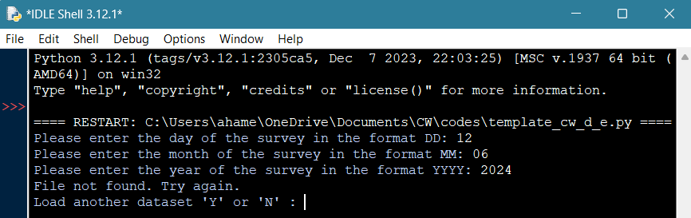

Figure 3 :case 3 outcomes

## Test case 4 outcomes

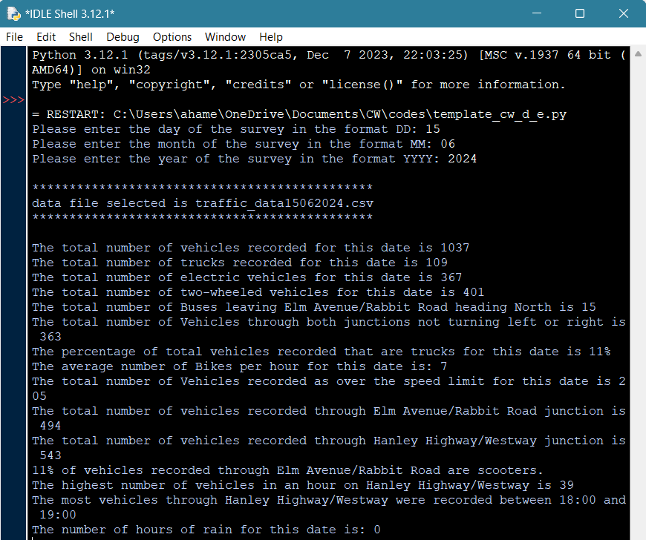

Figure 4: case 4 outcomes 1



Figure 5: case 4 outcomes 2

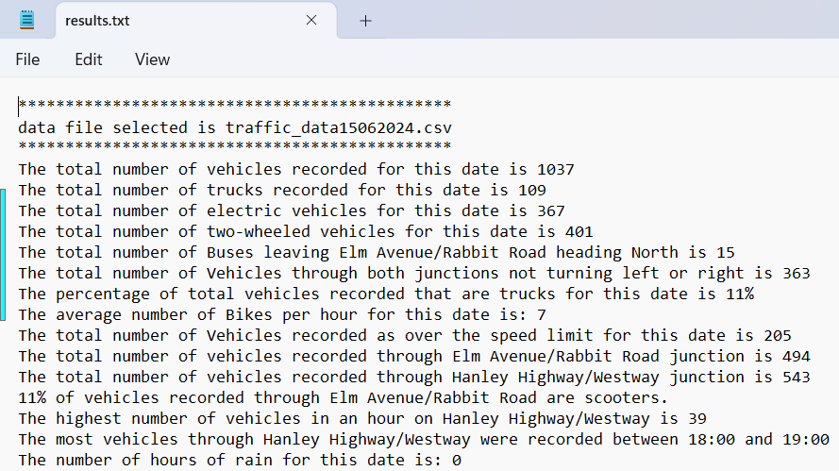

Figure 6: case 4 outcome 3

Figure 7: case 4 outcome 4

## Test case 5 outcomes

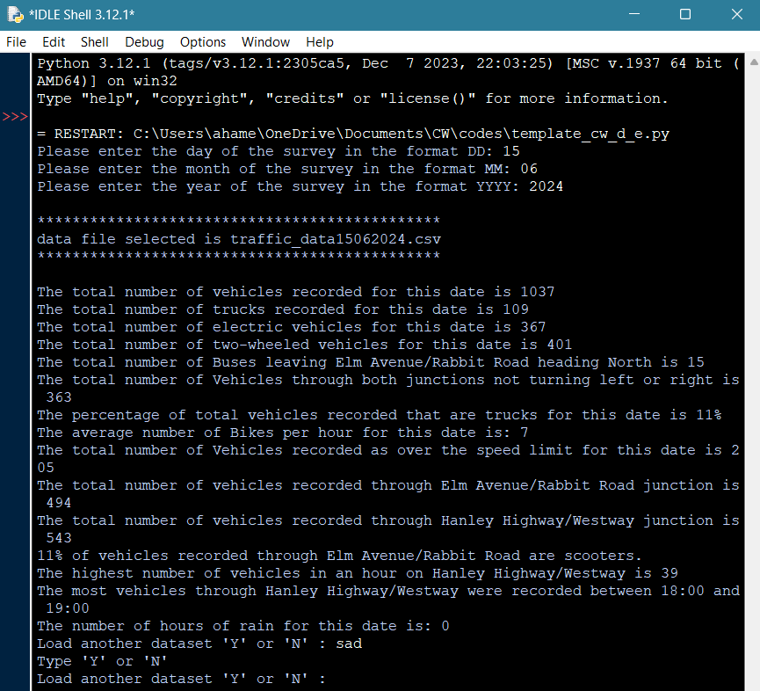

Figure 8: Case 5 outcomes

## Test case 6 outcomes

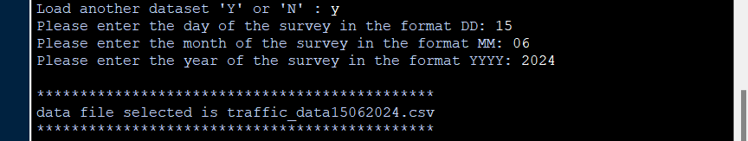

Figure 9 : case 6 outcomes 1



Figure 10 : case 6 outcomes 2